**LINUX**

Developed in September 1991 by Linus Trovalds.

Linux is a kernel (exposed to user) combined with other utilities. Instructions are given to the Machine which are then forwarded to the Kernel which then interacts with the Hardware. It is Open source. It had various versions like Red Hat, Ubuntu, Debian , SUSE etc.

* Powerful command line
* Extensible (add simple modules)
* Open Source
* Multi User
* Multiprogramming
* Portable (same software works on different Hardware)
* Stable and Robust (Less memory and CPU Footprints)
* Security (as it provides password protection and controlled access to specific files)

Using GUI at the end of OS you can interact with the Hardware. By using GUI you can directly interact with Hardware.

Writing commands in the Shell makes the OS/Machine understand the commands.

# prompt : root privileges (be cautious).

Linux has a bash Shell by default.

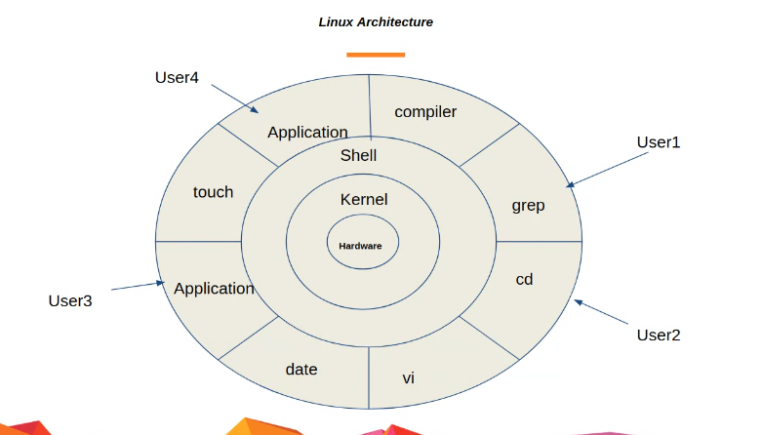

Sharing of CPU cycles: Multitasking.

Many programs running at the same time : Multiprogramming.

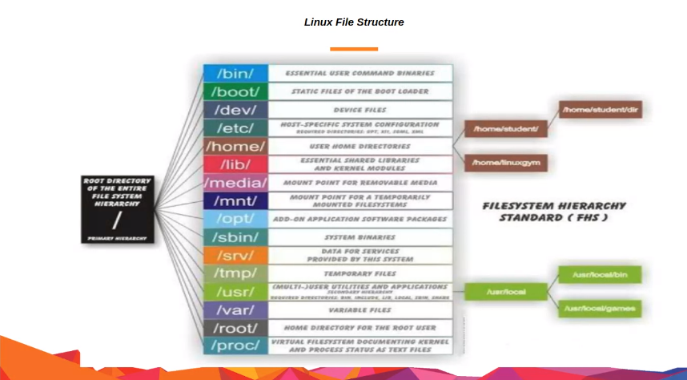

* Mkdir directory name : creates a new directory.
* Pwd : gves the complete path of the currents directory.
* Ls : shows the list of all contents in a current directory.
* Ls-l : displays contents in a listed format.
* Ls –al : also lists the hidden contents.
* Touch filename.extension : creates a file in the currents directory.
* NOTE : touch shimla.txt, now if shimla.txt already exists it will change the time stamp of the exixting file.
* . means current directory.
* .. means parent directory.
* Cd . is same as pwd
* Cat filename.extension displays the concatenated contents of the file.
* Cd : change directory
* Rm filename : deletes the file
* Rm-rf directory name : deletes the directory
* Which : searches for executables or shows the executable command
* Whereis : searches for executables and also tells about package that needs to run that executable.
* Find location –name(flag) name : eg find / or file /home/ searches the file in the given location with the provided name.
* Man command : gives the manual of that command
* Locate : also finds the file, not reliable but faster. It creates the index for all the files in a database/ server then searches in it.
* Adduser Chirag : adds an user with given name
* Sudo useradd Chirag : better practice to ad user in normal user mode
* Chown user owner : group owner filename : sets the user owner and group owner of the given file

NOTE : Sudo should be used by a normal user because of not complete rights.

* Chmod permission code filename :changes the persmission

NOTE : r=4,w=2,x=1

* Chmod u-w, chmod g-r, chmod o-x : can change the permission accordingly.(Here users minus write, group minus read, others minus executable)
* Chmod u+w, chmod g+r, chmod o+x : can change the permission accordingly.(Here users plus write, group plus read, others plus executable)
* Passwd username: used to change the password for current user
* Cal : calendar
* Echo “hey there”: displays hey there or can be used like echo “hey there” >> filename : changes the contents of the file to hey there.
* Userdel username : deletes the user
* Id username : returns various ids for username
* Useradd –u 1000 –g 500 –d/home/myhome/ username : useradded with mentioned ids
* Groupadd –g 500 groupname : adds a group with id 500 and given group name
* Usermod –u 1050 username : vhanges the u id for username to 1050
* Ls > file :no appending
* Ls>>file : appending
* Head -4 filename : displays top 4 lines of the file
* Less -3 filename : displays bottom 3 lines of the filename
* Cat filename | grep Shimal : pattern matching after whatever is written after grep
* Cat filename | grep –v Shimal : return everything that has no Shimla pattern
* More : displays one screen at a a time from beginning
* Less : displays one screen at a time from end
* Diff filename1 filename 2 : comparison in the contents of two mentioned files
* Wc –l (flag)| filename : return numbers of lines, words, characters n the basis of the flag

Soft Links are like shortcuts in Linux just like Chrome shortcut for Chrome browser in Windows.

Environment Variables : are used to set variables for particular environment as different application might need different environment, therefore we need to set environment variables for different environments.

When in a file you have two modes : command mode and insert mode. Press Insert to enter into Insert Mode and escape to go back to Command mode.

In insert mode you can add characters to the file by key stroking.

Yy to copy, dd to delete, w to save and p to paste when you are in command mode .

Vim filename : to enter into a file with above mode.

* Sudo Apt –install package : to install any package or application use apt command
* Top : returns the currently using processes
* Ps : snapshot of Top at the time when command wad executed, mostly used in debbuging
* Whoami : returns the user with which you logged in
* Su -b : to switch users, gets you from current user to user b
* Bash rc file : customize the shell, make it more personalized like creating alias

SSH helps you to remotely access the shell on other server after prompting you for a password through port 22.

* Scp : used to copy a file from one local server to another through port 22.
* Wget<link> : download from a link
* Export : exporting a variable
* History : to enlist all performed commands
* Ping : checks the connectivity